**Electrical components inside electrical box**

|  |  |  |  |
| --- | --- | --- | --- |
| QTY | Functie | Model/type | Leverancier - artikelnummer |
| 1 | Elektrokast 400x500x210mm | Rittal AE 1045.500 | [Conrad - 531738](https://www.conrad.nl/p/rittal-ae-1045500-schakelkast-400-x-500-x-210-plaatstaal-grijs-wit-ral-7035-1-stuks-531738) |
| 1 | 230V connector | 59JR101-1FR-LR | [Conrad - 736709](https://www.conrad.nl/p/apparaatstekker-42r-serie-connectoren-42r-stekker-inbouw-verticaal-totaal-aantal-polen-2-pe-10-a-zwart-k-b-59jr1-736709) |
| 1 | Emergency switch | 1233815 | [Conrad - 1233815](https://www.conrad.nl/p/deca-a20l-v4e02q6r-noodstopschakelaar-met-contactelement-240-vac-6-a-2x-nc-ip65-1-stuks-1233815) |
| 1 | Power supply 24V, 15A | POWER-S25024 - 24V | [Reprap World - 8719128324975](https://reprapworld.nl/products/elektronica/voeding/stroomadapter_24v_240_115v_15a_max/) |
| 1 | Power supply 12V, 30A | POWER-S25012-12V30A | [Reprap World - 8719128327037](https://reprapworld.nl/products/elektronica/voeding/stroomadapter_12v_240_115v_30a_max/) |
| 2 | Stepper driver R and Z | SDTB6600 9-42V, 3.5A | [Reprap World - 8719345004964](https://reprapworld.nl/products/elektronica/stappenmotordriver/tb6600_stappenmotor_3_5a_1_32_microstappen_9_42v/) |
| 2 | Stepper driver X and Y | SL2690A 20-90V, 6.5A | [Reprap World - 8719345005824](https://reprapworld.nl/products/elektronica/stappenmotordriver/sl2690a_stappenmotor_6_5a_1_128_microstappen_20_90v/) |
| 1 | 5V relay 1-channel high active | 5VRELHA | [TinyTronics - 000131](https://www.tinytronics.nl/shop/nl/diversen/relais/5v-relais-1-channel-hoog-actief?search=relais) |
| 1 | STM32 Nucleo-144 | NUCLEO-F439ZI | [Farnll - 2845532](https://nl.farnell.com/stmicroelectronics/nucleo-f439zi/dev-board-32bit-arm-cortex-m4/dp/2845532?ost=2845532&ddkey=https%3Anl-NL%2FElement14_Netherlands%2Fsearch) |
| 1 | Raspberry Pi 3 Model B+ 1GB | RPI3B+ | [TinyTronics - 001587](https://www.tinytronics.nl/shop/nl/raspberry-pi/main-boards/raspberry-pi-3-model-b-1gb-1?search=1587) |
| 1 | Ethernet cable | F6TP0,25RT | [Conrad - 1886785](https://www.conrad.nl/p/econ-connect-rj45-netwerk-aansluitkabel-cat-6-sftp-025-m-rood-pair-afscherming-1886785) |
| 2 | USB Adapter | NAUSB-W | [Farnell - 1760681](https://nl.farnell.com/neutrik/nausb-w/usb-adaptor-2-0-type-a-type-b/dp/1760681?ost=1760681&ddkey=https%3Anl-NL%2FElement14_Netherlands%2Fsearch) |
| 2 | USB-B cable | USB-BUSB30CM | [TinyTronics - 000927](https://www.tinytronics.nl/shop/nl/kabels/usb/usb-b-usb-kabel-30cm?search=927) |
| 2 | PC-ventilator | BL046 | [Conrad - 756546](https://www.conrad.nl/p/bequiet-pure-wings-2-pc-ventilator-zwart-b-x-h-x-d-120-x-120-x-25-mm-756546) |
| 2 | PC fan grille | GRM120-30 | [Conrad - 998782](https://www.conrad.nl/p/pc-fan-grille-with-filter-akasa-grm120-30-120-x-120-mm-998782) |
| 1 | Touchscreen | 7LCD1024X600TOUCHRPI | [TinyTronics - 001501](https://www.tinytronics.nl/shop/nl/raspberry-pi/accessoires/7-inch-lcd-display-1024*600-pixels-met-touchscreen-raspberry-pi-compatible?search=1501) |
| 1 | HDMI cable | HDMICABLE1M | [TinyTronics - 001270](https://www.tinytronics.nl/shop/nl/kabels/hdmi/hdmi-kabel-1m?search=hdmi) |
| 2 | Plug-in bridge - FBS 4-5 | Phoenix Contact FBS 4-5 | [Conrad - 744072](https://www.conrad.nl/p/geleiderbrug-fbs-4-5-phoenix-contact-inhoud-1-stuks-744072) |
| 44 | Feed-through terminal block | Phoenix Contact UT2,5 | [Conrad - 744725](https://www.conrad.nl/p/phoenix-contact-ut-25-3044076-doorgangsklem-aantal-polen-2-014-mm-4-mm-grijs-1-stuks-744725) |

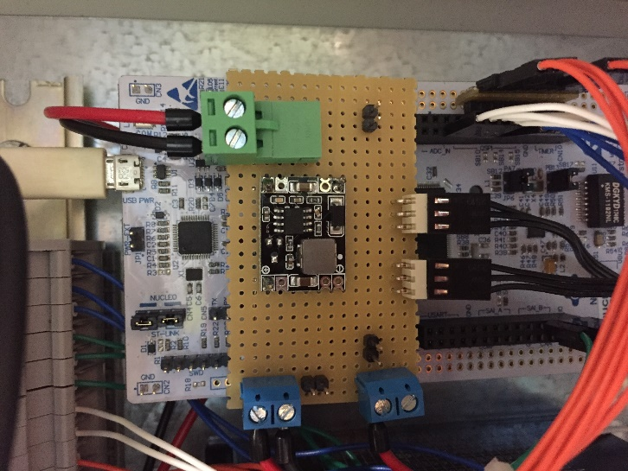**Nucleo Shield Components inside electrical box**

|  |  |  |  |
| --- | --- | --- | --- |
| QTY | Functie | Model/type | Leverancier - artikelnummer |
| 1 | Voltage converter | DCDCSTEPDOWN5V | [TinyTronics - 001319](https://www.tinytronics.nl/shop/nl/spanning-converters/step-down/dc-dc-step-down-buck-converter-1.5a-5v-output?search=1319) |
| 2 | Fan connector | 1580964 | [Conrad - 1580964](https://www.conrad.nl/p/tru-components-male-header-standaard-totaal-aantal-polen-3-rastermaat-254-mm-1580964-1-stuks-1580964) |
| 2 | 2 pin screw terminal | PM 5.08/2/90 3.5 SW -1760510000 | [RS - 425-8720](https://nl.rs-online.com/web/p/pcb-terminal-blocks/4258720/) |
| 1 | Pluggable Terminal Block PCB header | 691313510002 | [RS - 826-7494](https://nl.rs-online.com/web/p/pcb-terminal-blocks/8267494/) |
| 1 | Pluggable Terminal Block | 1758364 | [RS - 802-5919](https://nl.rs-online.com/web/p/pcb-terminal-blocks/8025919/) |

**Raspberry Pi Shield Components inside electrical box**

|  |  |  |  |
| --- | --- | --- | --- |
| QTY | Functie | Model/type | Leverancier - artikelnummer |
| 1 | Voltage converter | XL6009UPDOWN | [TinyTronics - 001319](https://www.tinytronics.nl/shop/nl/spanning-converters/step-up/dc-dc-verstelbare-step-up-down-buck-boost-converter-xl6009-4a?search=290) |
| 2 | 2 pin screw terminal | PM 5.08/2/90 3.5 SW -1760510000 | [RS - 425-8720](https://nl.rs-online.com/web/p/pcb-terminal-blocks/4258720/) |
| 1 | Mini RS232 to TTL converter | MAX3232 | [OpenCircuit - 34764](https://opencircuit.nl/Product/11581/MAX3232-Mini-RS232-naar-TTL-converter) |
| 2 | PCB Terminal Block | 1725656 | [RS- 220-4260](https://nl.rs-online.com/web/p/pcb-terminal-blocks/2204260/) |

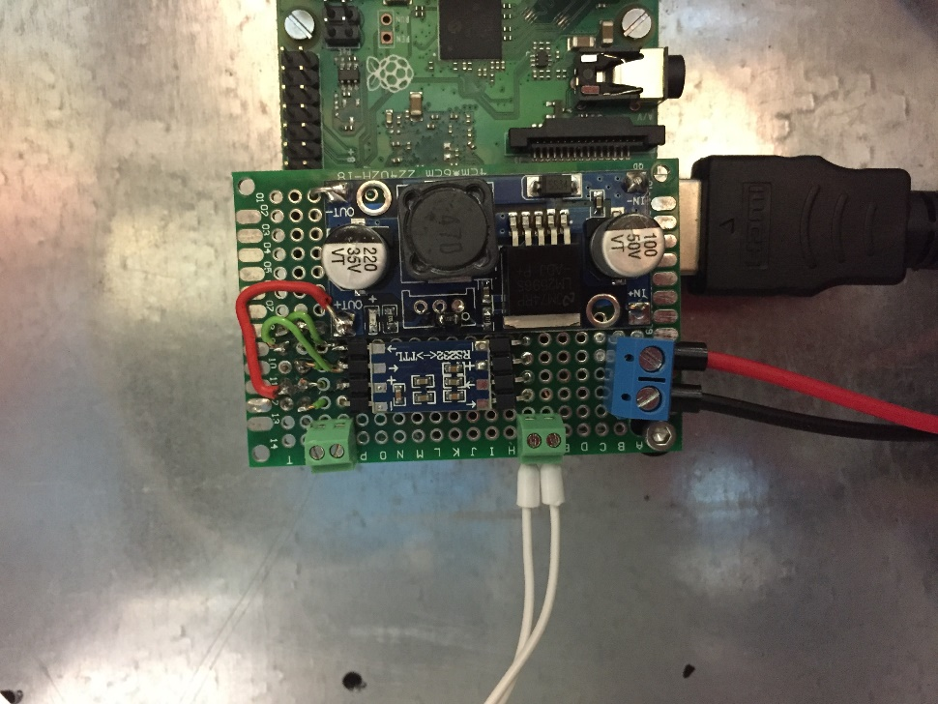

**Electrical components outside electrical box**

|  |  |  |  |
| --- | --- | --- | --- |
| QTY | Functie | Model/type | Leverancier - artikelnummer |
| 2 | Stepper Motor NEMA17 | SL42S247A | [Reprap World - 8719345003981](https://reprapworld.nl/products/motoren_fans/stappenmotoren/nema17_stappenmotor_1_8_stap_stekker_platte_as_5_0_kg_cm/) |
| 1 | Stepper Motor NEMA23 | SMNM23S18KG31 | [Reprap World - 8719345005800](https://reprapworld.nl/products/motoren_fans/stappenmotoren/nema23_stappenmotor_1_8_stap_30_59_kg_cm) |
| 1 | Nema 24 Stepper w/ Brake | 24HS39-4204D-B200 | [Stepperonline - 24HS39-4204D-B200](https://www.omc-stepperonline.com/nema-24-stepper-40nm566-ozin-w-brake-friction-torque-20nm283ozin-24hs39-4204d-b200.html?search=brake) |
| 5 | Panasonic lightswitch F-type | PM-F65W-P | [Conrad - 1547476](https://www.conrad.nl/p/panasonic-pm-f65w-p-vorklichtsluis-f-type-lichtschakelend-donkerschakelend-5-24-vdc-1-stuks-1547476) |
| 2 | Panasonic lightswitch | PM-Y65-P | [Conrad - 1547442](https://www.conrad.nl/p/panasonic-pm-y65-p-vorklichtsluis-y-type-lichtschakelend-donkerschakelend-5-24-vdc-1-stuks-1547442) |
| 1 | Panasonic CN14AC1 light switch cable (1m) | CN14AC1 | [Conrad - 1429076](https://www.conrad.nl/p/panasonic-cn14ac1-aansluitkabel-serie-cn14-uitvoering-algemeen-aansluitkabel-1429076) |
| 1 | Panasonic CN14AC3 light switch cable (3m) | CN14AC3 | [Conrad - 1429107](https://www.conrad.nl/p/panasonic-cn14ac3-aansluitkabel-serie-cn14-uitvoering-algemeen-aansluitkabel-1429107) |
| 5 | Panasonic CN14AC5 light switch cable (5m) | CN14AC5 | [Conrad - 1429077](https://www.conrad.nl/p/panasonic-cn14ac5-aansluitkabel-serie-cn14-uitvoering-algemeen-aansluitkabel-1429077) |
| 3 | Load cell – 5kg | LOADCELL5KG | [Tinytronics - 000951](https://www.tinytronics.nl/shop/nl/sensoren/gewicht-druk-kracht/load-cell-5kg) |
| 3 | Load Cell Amplifier - HX711 | HX711MOD | [TinyTronics - 000747](https://www.tinytronics.nl/shop/nl/sensoren/gewicht-druk-kracht/load-cell-versterker-hx711?search=747) |
| 1 | Voltage converter | DCDCSTEPDOWN5V | [TinyTronics - 001319](https://www.tinytronics.nl/shop/nl/spanning-converters/step-down/dc-dc-step-down-buck-converter-1.5a-5v-output?search=1319) |
| 1 | Mini RS232 to TTL converter | MAX3232 | [OpenCircuit - 34764](https://opencircuit.nl/Product/11581/MAX3232-Mini-RS232-naar-TTL-converter) |
| 1 | Barcode Scanner Module – 1D/2D | WS-14810 | [Kiwi Electronics - WS-14810](https://www.kiwi-electronics.nl/barcode-scanner-14810) |
| 1 | GX16-4 Connector Set | GX16-4 | [TinyTronics - 001081](https://www.tinytronics.nl/shop/nl/connectoren/overige/gx16-4-connector-set?search=1081) |
| 1 | GX16-6 Connector Set | GX16-6 | [TinyTronics - 001593](https://www.tinytronics.nl/shop/nl/connectoren/overige/gx16-6-connector-set?search=Connector%20Set) |